**M8D28PM – M2D35PM (diluted 1:100)**

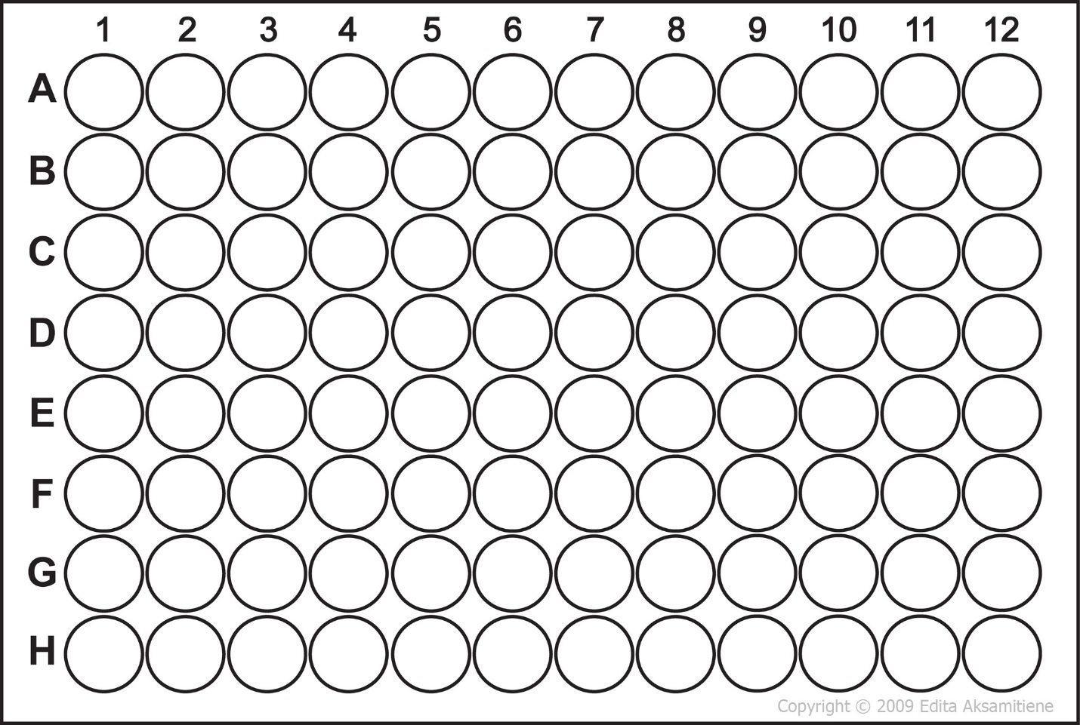

3d31pm

4d30am

2d32

10d31pm

9d31pm

8d31pm

7d31pm

6d31pm

5d31pm

4d31pm

2d31pm

2d30am

2d359m

10d35am

9d35am

8d35am

7d35am

6d35am

5d35am

4d35am

3d35am

2d35am

10d33

9d33

8d33

7d33

6d33

5d33

4d33

3d33

2d33

10d32

9d32

8d32

7d32

6d32

5d32

4d32

3d32

10d31am

7d30pm

8d30pm

9d30pm

10d30pm

2d31am

3d31am

4d31am

5d31am

6d31am

7d31am

8d31am

9d31am

6d30pm

5d30pm

4d30pm

3d30pm

2d30pm

10d30am

9d30am

8d30am

7d30am

6d30am

5d30am

3d30am

10d29pm

9d29pm

8d29pm

7d29pm

6d29pm

5d29pm

4d29pm

3d29pm

2d29pm

1d29pm

10d29am

9d29am

8d29am

7d29am

6d29am

5d29am

4d29am

3d29am

2d29am

1d29am

9d28pm

8d28pm